After setting up the project and we will get two user : 1) admin 2) user

Steps in short:

->php artisan migrate:fresh

->php artisan passport:client –personal

inzerted

->php artisan db:seed

Both admin and user has password : 123123

**Login API :**

<url:http://localhost:8000/api/login>

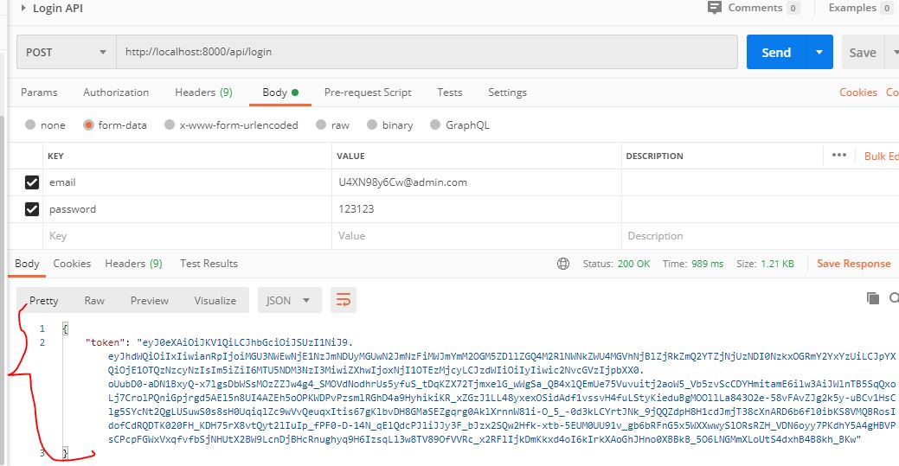

Here we will get token, which will be required for rest of the API call.

'headers' => [

    'Accept' => 'application/json',

    'Authorization' => 'Bearer '. $token,

]

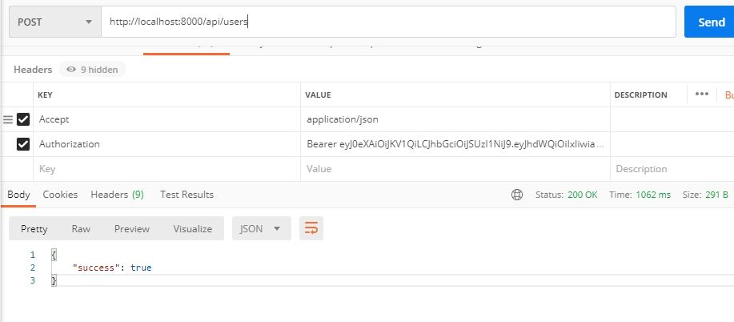

**Create user API :**

can be created only by admins.

**url:** <http://localhost:8000/api/users>

method: POST

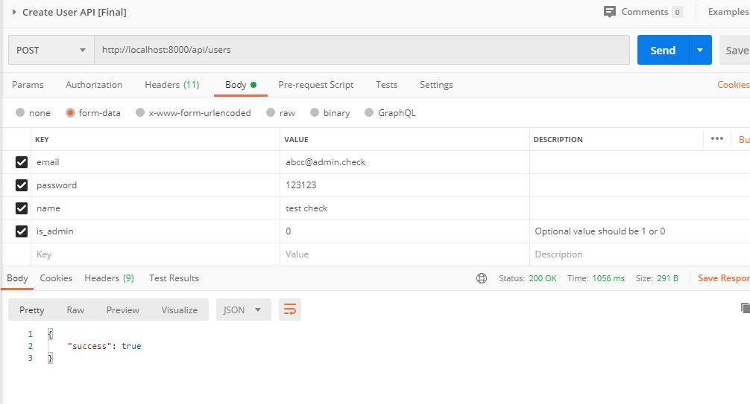

**Edit User API:**

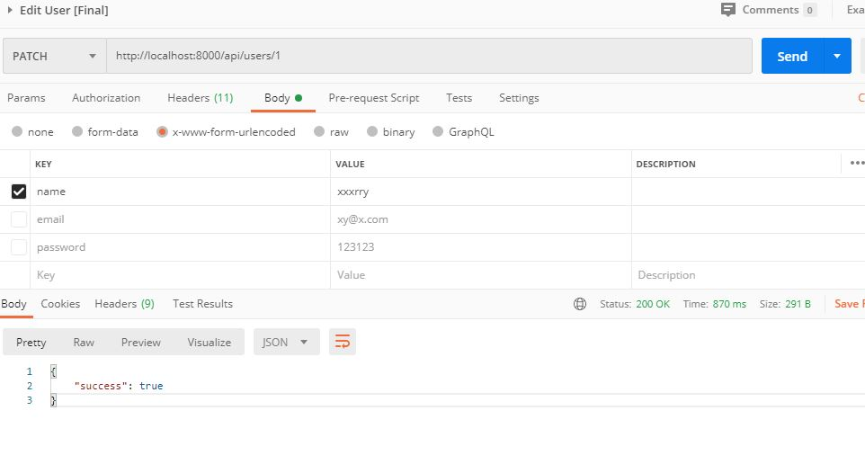

**Delete User API**

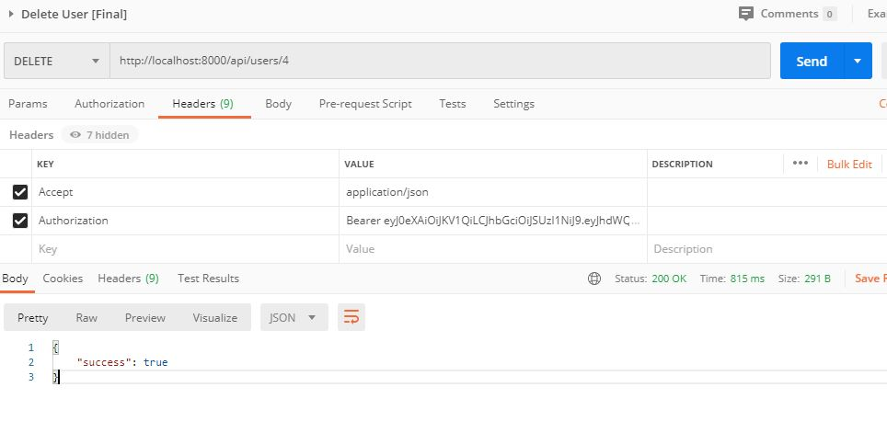

**Create Project API**

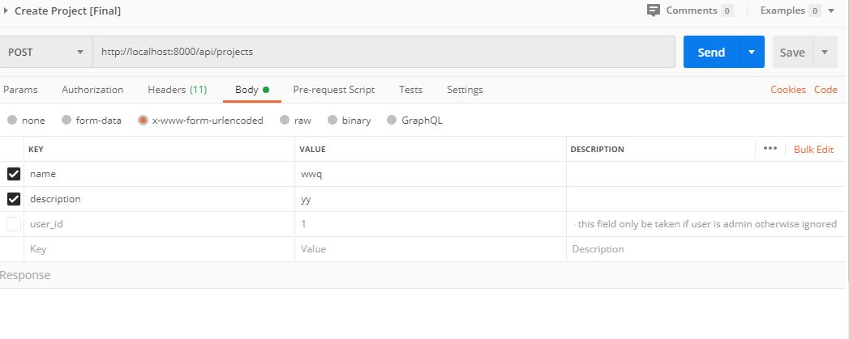

**Edit Project:**

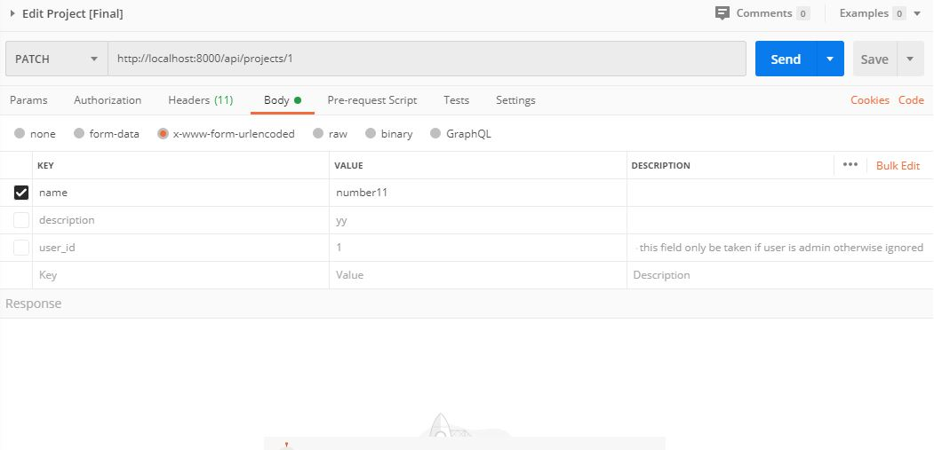

**Delete project:**

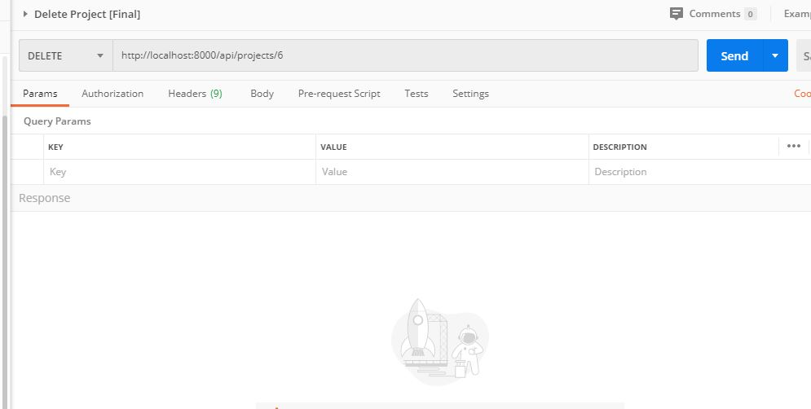

**Logs:**

